Phishing Email Identification Report

Phishing Email Sample

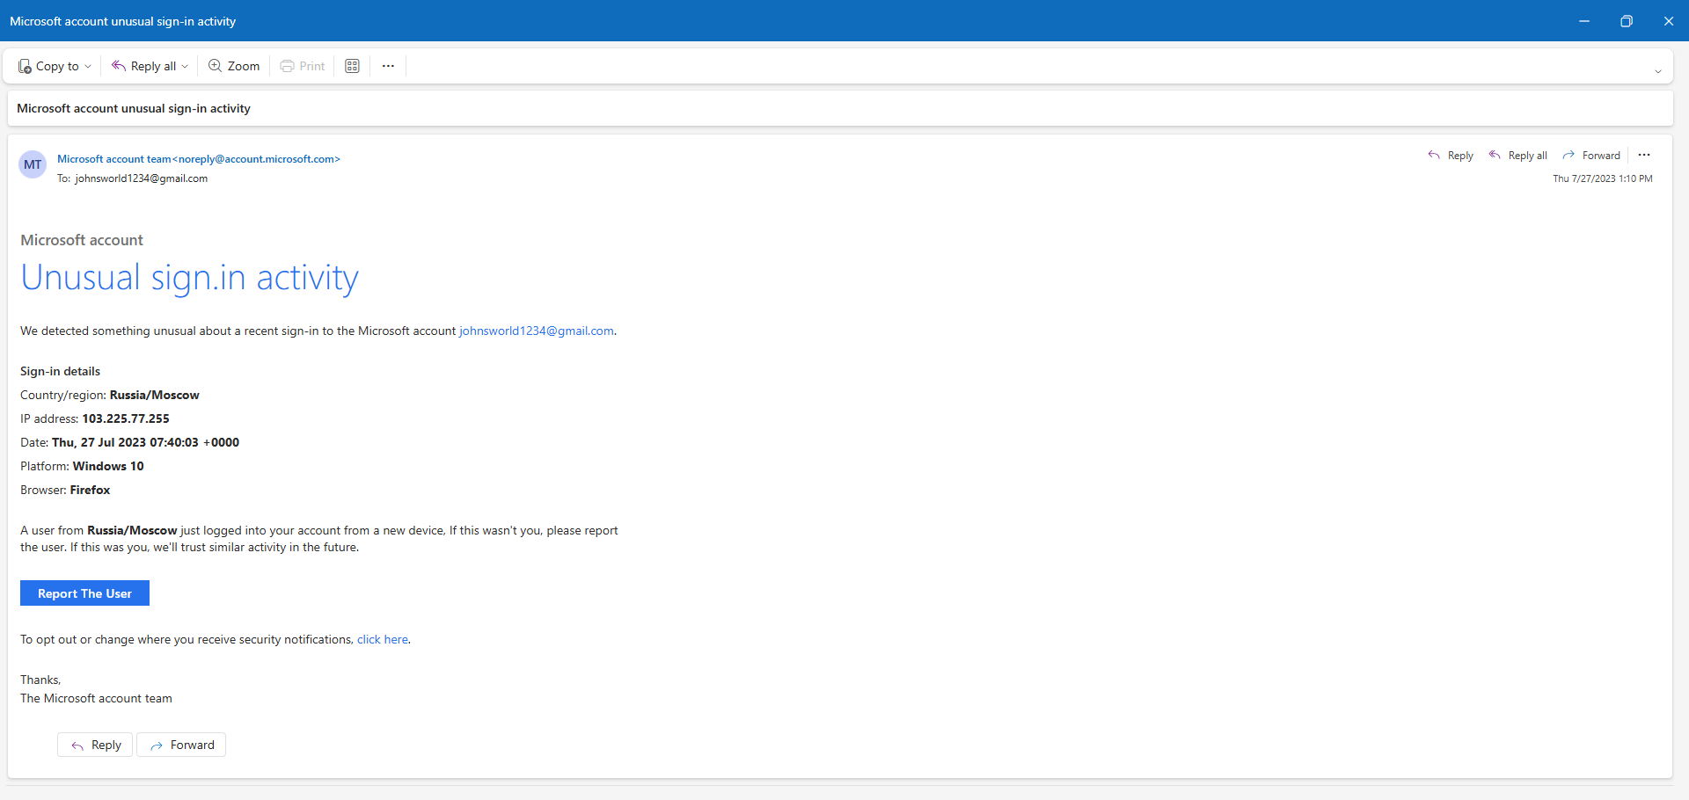
Fig 1. Phishing Mail
From: Microsoft Support <noreply@account.microsoft.com>
Subject: Microsoft account unusual signin activity
Body:
Microsoft account
Unusual sign.in activity
We detected something unusual about a recent sign-in to the Microsoft account johnsworld1234@gmail.com.
Sign-in details
Country/region: Russia/Moscow
IP address: 103.225.77.255
Date: Thu, 27 Jul 2023 07:40:03 +0000
Platform: Windows 10
Browser: Firefox
A user from Russia/Moscow just logged into your account from a new device, If this wasn't you, please report the user. If this was you, we'll trust similar activity in the future.
Report The User
To opt out or change where you receive security notifications, click here.
Thanks,
The Microsoft account team
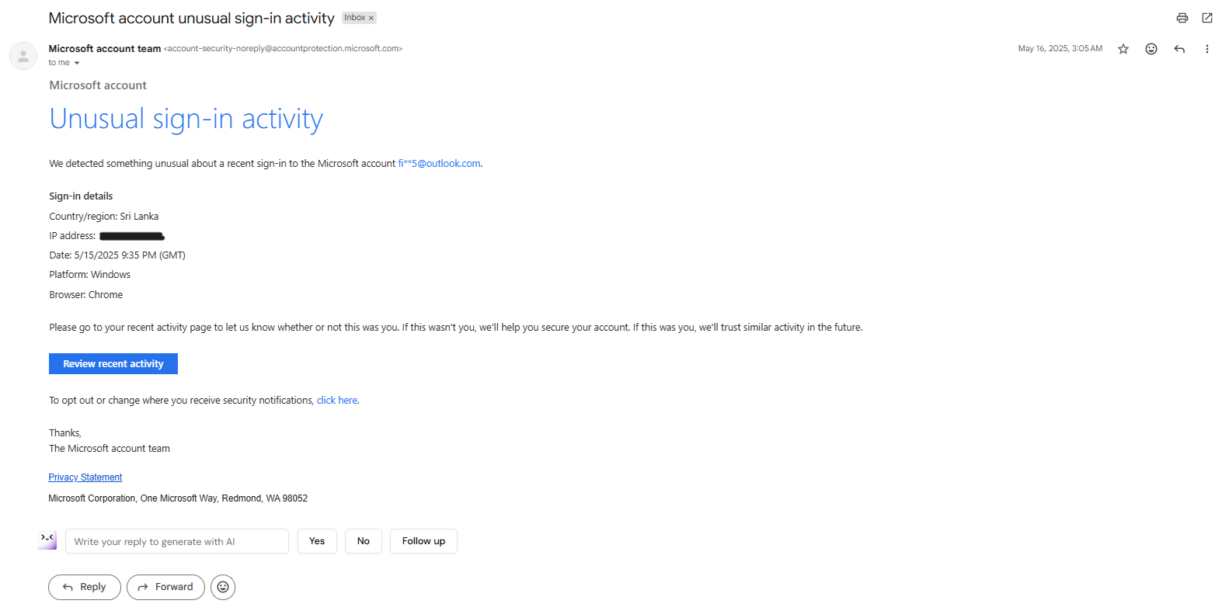
Fig 2. Original Mail

Analyzing the Sample Email

1. Examine sender's email address for spoofing:
The sender appears as Microsoft Support <noreply@account.microsoft.com>. Although this domain looks legitimate, attackers often spoof Microsoft domains using forged headers. Without proper authentication results (SPF, DKIM, DMARC), the sender cannot be trusted. The legitimate address is <account-security-noreply@accountprotection.microsoft.com>

2. Check email headers for discrepancies (using online header analyzer):

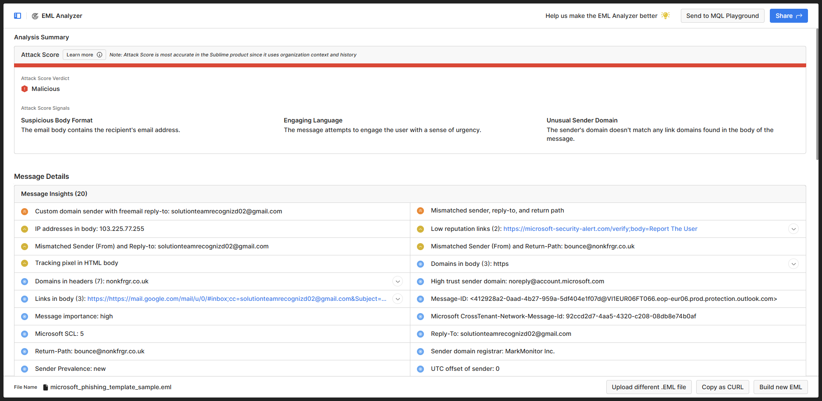
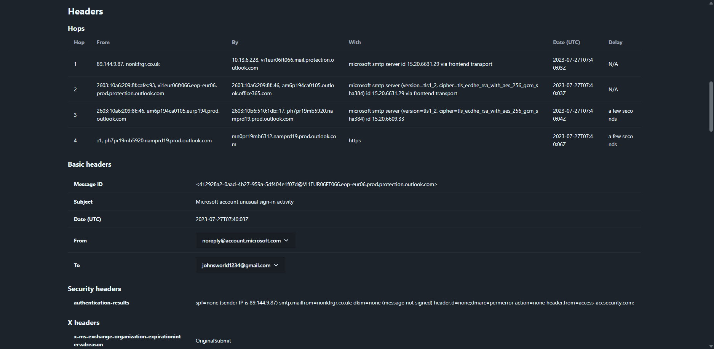
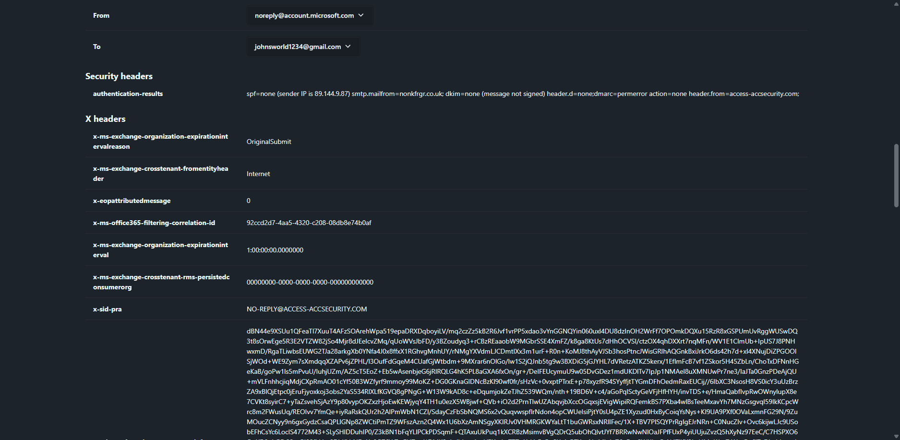
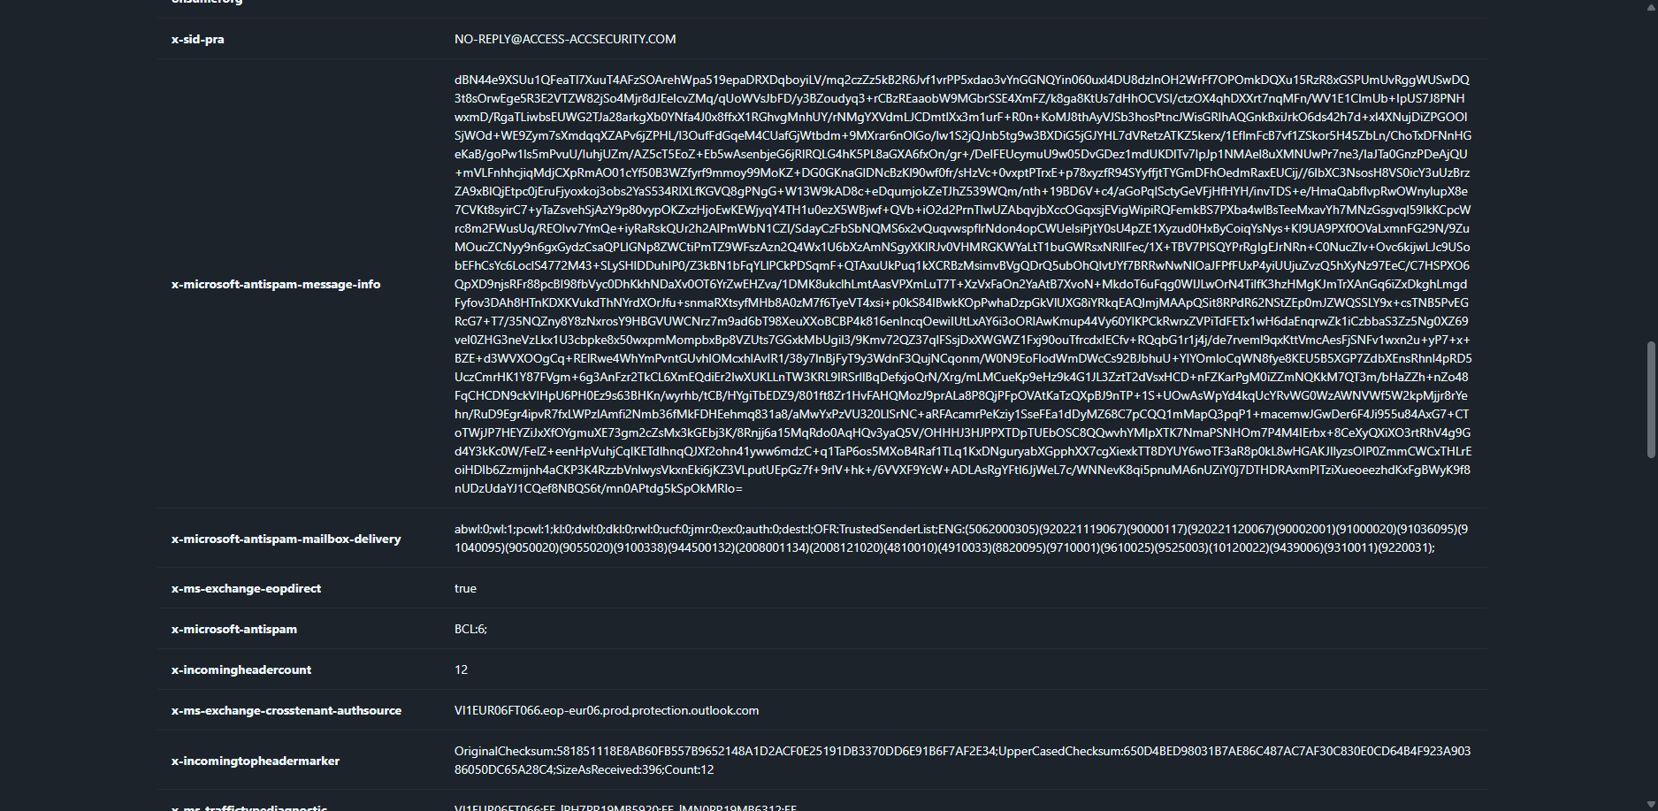
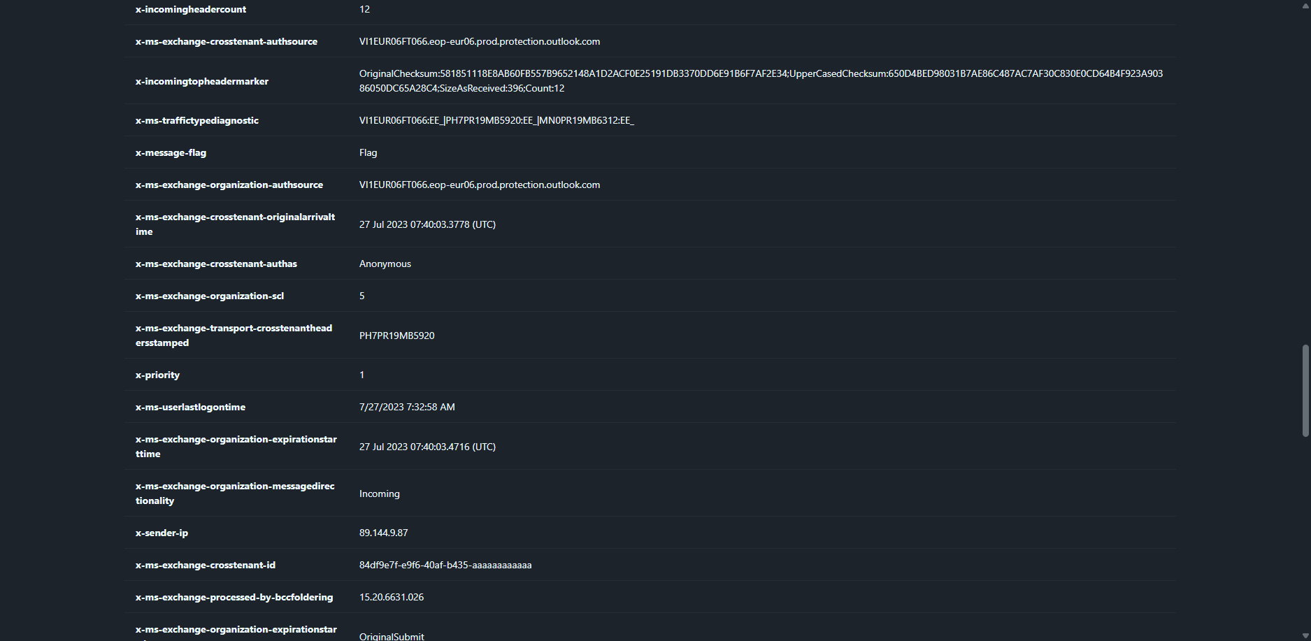
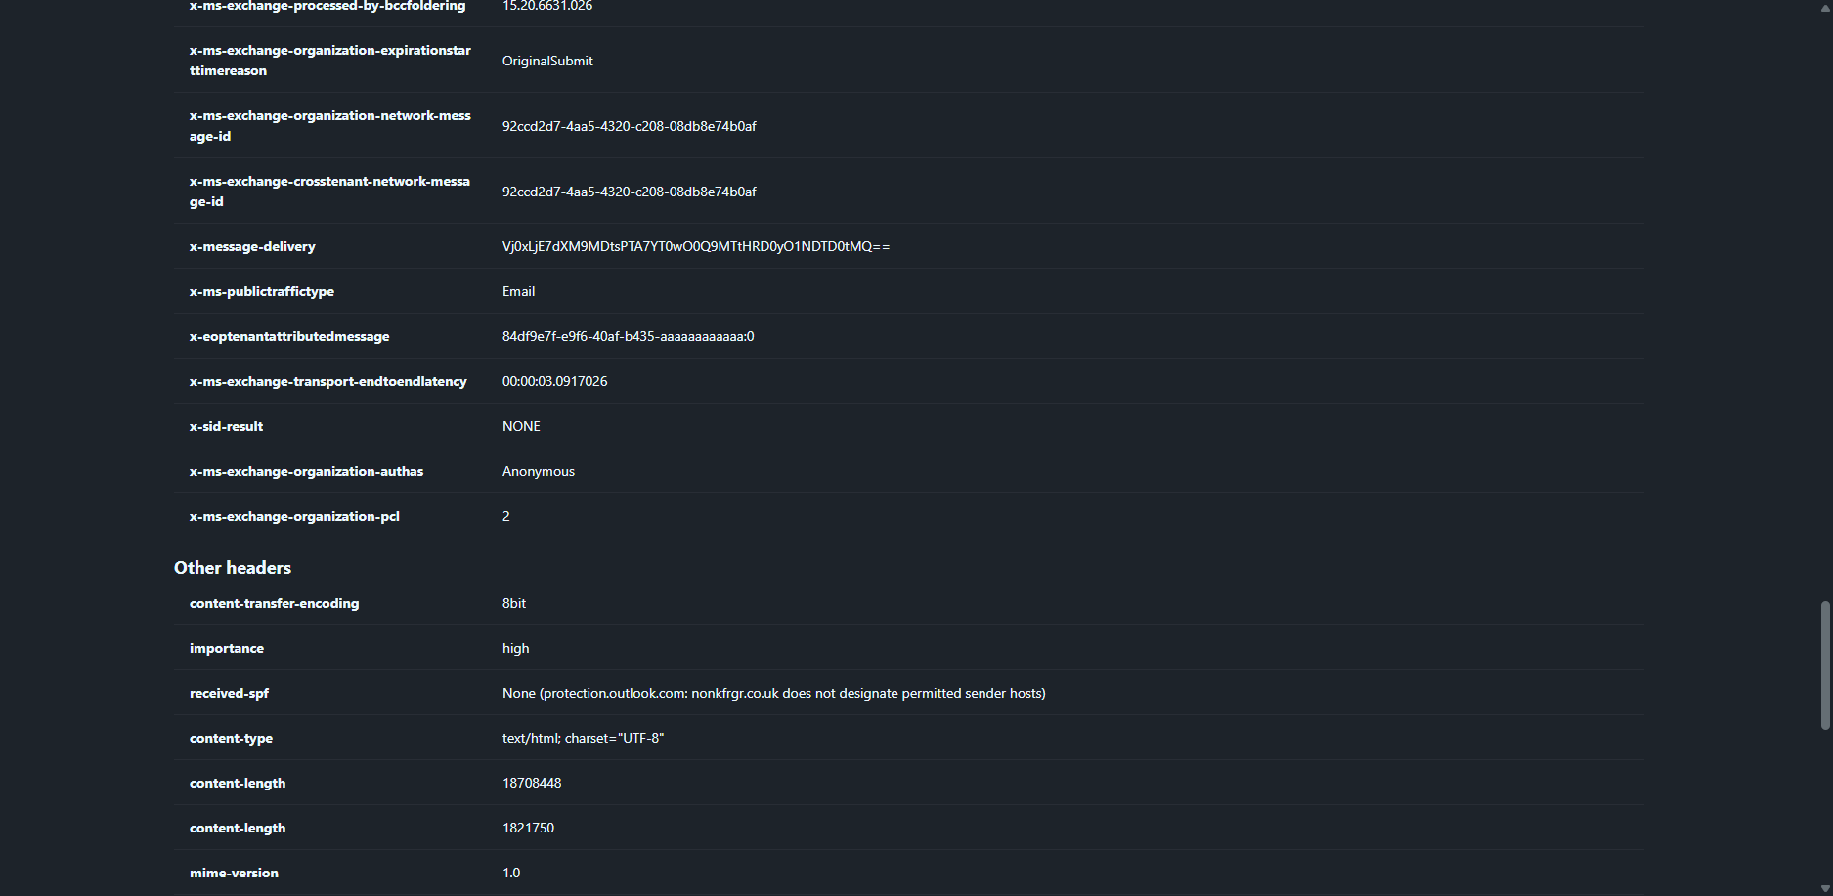
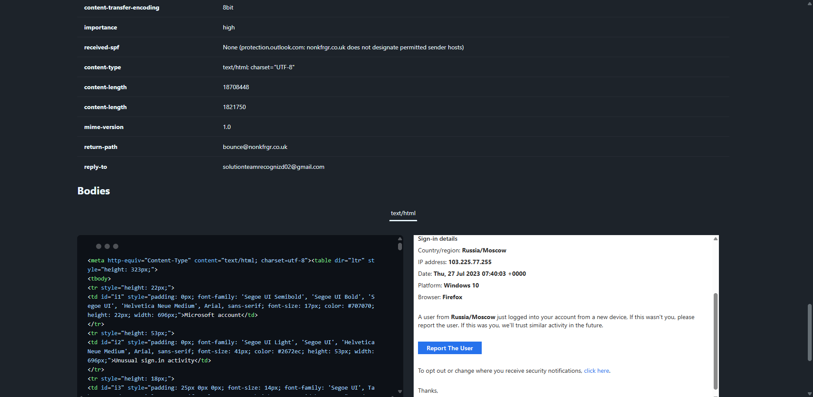
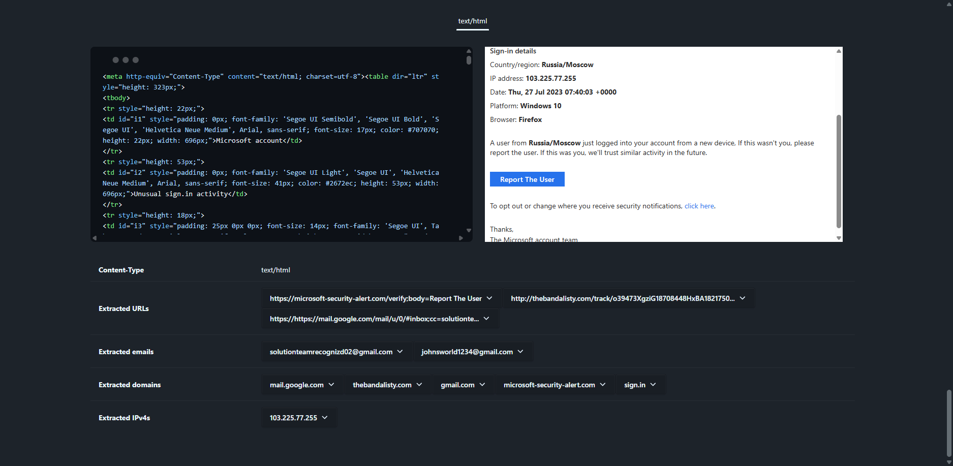
The email header analysis reveals several clear discrepancies indicating spoofing. The SPF check shows SPF=none, meaning the sender IP (89.144.9.87) is not authorized to send mail on behalf of the claimed Microsoft domain. Additionally, DKIM is not signed and DMARC results show failure, both of which are strong indicators of an unauthenticated and potentially fraudulent email. The Return-Path is set to bounce@nonkfrgr.co.uk, a domain completely unrelated to Microsoft, further confirming sender impersonation. Overall, the combination of failed authentication checks, mismatched domains, and suspicious IP origins strongly suggests the email was not legitimately sent from Microsoft servers.

3. Identify suspicious links or attachments:
The email includes action links such as 'Report The User' and 'click here'. These may redirect to fraudulent Microsoft login pages designed to steal credentials. There are no attachments, which is typical for credential‑harvesting phishing emails.

4. Look for urgent or threatening language in the email body:
The email claims a login occurred from Russia, creating fear. It urges the user to report the activity immediately, pushing them toward quick action without verifying legitimacy.

5. Note any mismatched URLs (hover to see real link):
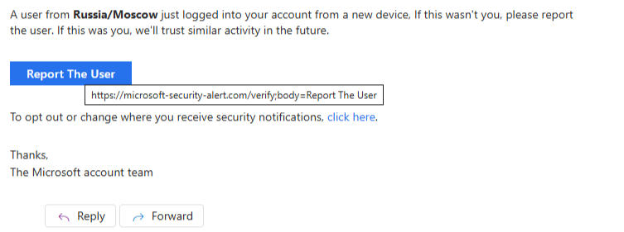
Displayed links may appear legitimate, but hovering over them often reveals a malicious URL unrelated to Microsoft services. Here, when hovering over the “Report The User” box we can see the redirection mail is given as https://microsoft-security-alert.com/verify which is a malicious link created by the attacker to capture the victims credentials. The original url for the same is https://account.microsoft.com/activity. Attackers frequently mask hostile URLs behind trusted text.

6. Verify presence of spelling or grammar errors:
Errors such as 'sign.in' instead of 'sign-in', inconsistent capitalization, and awkward sentence structure indicate the email is not professionally generated. Genuine Microsoft emails follow strict formatting and style guidelines.

7. Summarize phishing traits found in the email:
The email demonstrates several phishing red flags: suspicious sender domain, urgency-based manipulation, login alert used as emotional bait, presence of potentially malicious links, and grammatical inconsistencies. These combined signs strongly classify the email as a phishing attempt.

